


NOMINATION FORM
Any individual who is over 70 and lives in Calgary or its surrounding communities is eligible to be nominated. Ideal nominees are those who have started something different or new, or implemented a new venture or idea, AFTER age 70. The focus of the awards isn’t on past accomplishments or lifetime achievements. Rather, individuals should be nominated for new accomplishments. These achievements may be based or built on previous work or commitments, but they should have a “current” flavour or different twist, or perhaps be occurring in a completely new arena.

Nominees’ accomplishments can be occurring in fields such as: health, wellness and recreation; arts and culture; science; business; volunteerism; environment; overcoming adversity; and making a difference.

To that end, the awards raise funds for InterGen — a unique talent development program and matching platform. This program is helping to re-energize our economy by partnering transitioning or retiring individuals with younger entrepreneurs, thus creating multigenerational teams that can rapidly scale growth.

For a complete list of guidelines, please see https://top7over70.com/nominate/.

How to nominate an individual for a Top 7 Over 70 Award:

- Complete the nomination form below.
- Ensure you have contacted your nominee and obtained his/her permission to enter him/her in this award.
- Talk to two other people who know the nominee and obtain a letter of support for this nomination from each of them. (Details on the letter of support are below.)
- Gather the completed nomination form and two letters of support and email them to top7over70@humaniscalgary.com OR printed nominations and material can be submitted to: Top 7 Over 70; c/o Cameron McDonald – Humanis Talent Acquisition & Advisory; Suite 300, 110 – 9th Avenue SW, Calgary AB T2P 0T1. Additional questions can be directed to Cameron McDonald – (403)-407-1965.
- Nominations should be received by Sunday, June 15th, 2025.
- If you have questions, email top7over70@humaniscalgary.com.
- Award recipients will be celebrated at a Top 7 Over 70 Gala on Tuesday, October 21, 2025. Gala details are at https://top7over70.com/gala/. Note: Winners will be made public at a media launch/awardee lunch prior to the Gala.

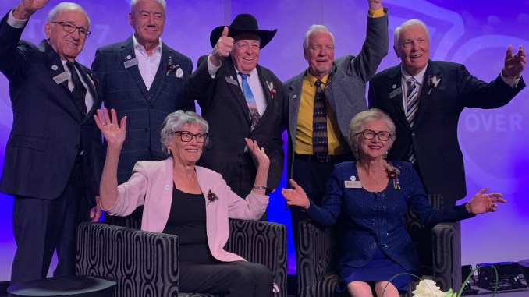
2023 Top 7 Over 70 Award Recipients

NOMINEE INFORMATION

Title: Ms Mrs. Mr. Dr. Other
Name:
Address:
City or town: Postal Code:
Email address:
Phone: Mobile:
Date of birth:
Please confirm the following statement with your initials:

I’ve informed the nominee that I’ve put his/her name forward for this award. He/she consents to have this nomination put forward and have his/her name included in any Top 7 Over 70 properties, such as the organization’s website, event program and news releases. (initial)
NOMINATOR CONTACT INFO

Title: Ms. Mrs. Mr. Dr. Other
Name:
Address:
City or town: Postal Code:
Email address:
Phone: Mobile:

TELL US ABOUT THE NOMINEE (Please complete all sections)

ACHIEVEMENT(S) AFTER AGE 70
Please list achievement(s) the nominee has accomplished after turning 70 within any of the following fields: health, wellness and recreation; arts and culture; science; business; volunteerism; environment; overcoming adversity; and making a difference. Please be specific.

WHY DOES THIS INDIVIDUAL DESERVE A TOP 7 OVER 70 AWARD?
Please specifically address this within the context of the aforementioned achievements. Supplementary information may be included on a separate page.

HOW DOES THIS INDIVIDUAL INSPIRE THOSE AROUND HIM/HER?
How has this individual’s accomplishments past the age of 70 inspired others?

ORGANIZATIONS / COMMUNITY MEMBERSHIPS
Please tell us about other memberships or organizations the nominee is involved in, along with a brief summary of responsibilities or contributions:

LETTERS OF SUPPORT

Each nomination requires two letters of support. These letters should explain why the letter writer believes the nominee deserves a Top 7 Over 70 award and discuss how the nominee has accomplished a milestone or vision that inspires Albertans of all ages, demonstrating that age does not preclude developing new passions. Family members can be involved in nominating and supporting a nominee. Nominators and supporters can live anywhere, but we do need a phone number and email for each of them.

* Please collect these letters and include them with your nomination package. Please list the names of the individuals who will be writing letters of support:

Name:
Email: Phone:

Name:
Email: Phone:

Thank you for taking the time to nominate the worthy individual you know!

Email completed forms online to:
top7over70@humaniscalgary.com

Or, printed forms can be submitted to:
Top 7 Over 70
c/o Cameron McDonald – Humanis Talent Acquisition & Advisory.
Suite 300, 110 – 9th Avenue SW
Calgary, AB.
T2P 0T1

