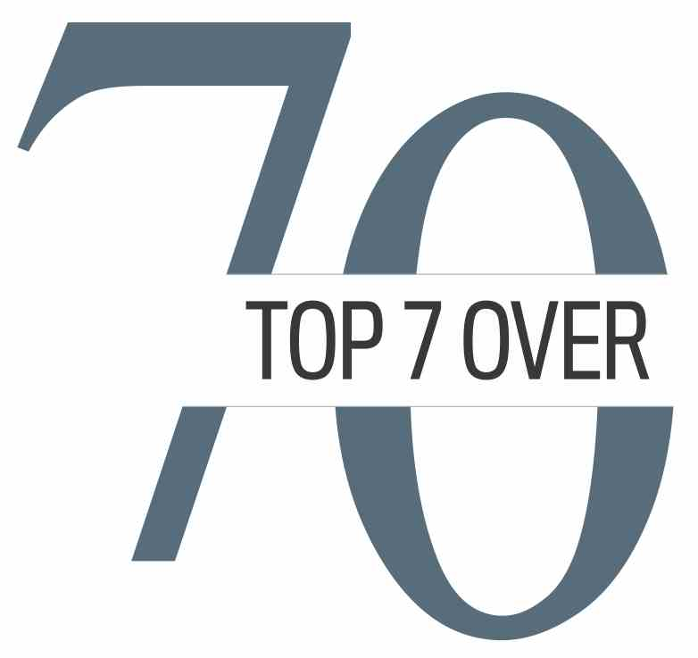
FEB. 1, 2021: NEWS RELEASE
Seniors making a difference: Meet the latest recipients of the Noble Neighbour Citations
Website: www.top7over70.com

The Top 7 Over 70 program is pleased to announce the latest recipients of its new Noble Neighbour Citations — a program designed to recognize the community work of seniors during the pandemic.
“Seniors are truly making their communities a better place during these challenging times,” says Top 7 Over 70 committee chairman Kim McConnell. “They’re taking on a wide variety of tasks and helping their neighbours in many ways, big and small.”
In recognition of seniors’ contributions, Top 7 Over 70 created the Noble Neighbour Citations late last year. The first recipient, Anne Drabble, received her award in December. She’s made 200-plus face masks, all of which have been donated to others.
Today, we are announcing our next two recipients:
- Gerry Burger-Martindale: A Calgary Public Library retiree, Burger-Martindale spent her career assisting others. During the pandemic, she has taught online English Language Learning classes to new Canadians; she’s delivered library books through a “home bound” reader program; she became chair of the Student Awards Selection Committee for EducationMatters, a program that enhances public education for Calgary students; and, she joined the board of the Skipping Stone Foundation, which supports and connects trans and gender diverse youth, adults and their families.
- Debbie Dunwell: As founder and executive director of the Simply Compassion Advocacy Society, Debbie Dunwell assists seniors and people who are in palliative stages of care. She’s overseen virtual concerts, letter and Christmas card campaigns, and phone visitation programs for seniors.

To set up interviews or book an interview for your show:
- To interview Kim McConnell, contact him at 403-862-5818; Kim@KimMcConnell.ca
- To set up an interview with a Noble Neighbour recipient, contact Monica at 403-875-1222 or top7over70@gmail.com.
FAQS on the new Noble Neighbour Citations Program
Why has Top 7 Over 70 started the Noble Neighbour program?
We live in extraordinarily challenging times and we want to recognize some of the people doing extraordinary things to help their communities during this unique period. There are so many seniors stepping up and helping out, wherever and whenever they can. We want to recognize these contributions.

Does the Noble Neighbour program impact the biennial Top 7 Over 70 program?
No, not at all. The Top 7 Over 70 program is still going ahead as scheduled in 2021. The two programs are complementary. While Top 7 Over 70 awards require significant successes achieved by people after age 70, the Noble Neighbour program is a quick turn-around program that allows us to celebrate seniors in a different way. It allows us to reach into so many more communities and celebrate the rich offerings from all corners of our beautifully diverse population. Applying for a Noble Neighbour citation is a less intensive process than applying for a Top 7 Over 70 award. It takes just a few paragraphs on an application form that explain why a senior has proven to be a Noble Neighbour. Seniors can either apply for a citation on their own, or someone who knows them can apply for the citation on their behalf at https://intergenconnect.com/nobleneighbour/
Applications sent before the last day of each month will be considered for citations given out the following month. All applications stay on file from month to month. No applications will be accepted after May 31, 2021.

How many Noble Neighbour Citations will be given out?
The number of citations awarded will depend on the quality of applications received. We plan on awarding a number of citations at the start of each month from January to June. Any senior in Calgary and area who has helped a neighbour or community during the pandemic is eligible to apply.

About the Top 7 Over 70 Awards
The biennial awards (occurring every two years) recognize seven individuals who are achieving excellence in one or more of a myriad of fields, focusing on achievements started after age 70. Application forms can be found at https://intergenconnect.com/top7/ . While Top 7 Over 70 nominations are accepted until Aug. 15, we encourage you to submit your nomination early so that the selection panel has ample time to consider your nominee. The format of the 2021 awards ceremony will be determined in accordance with health and safety guidelines in effect at that time.

