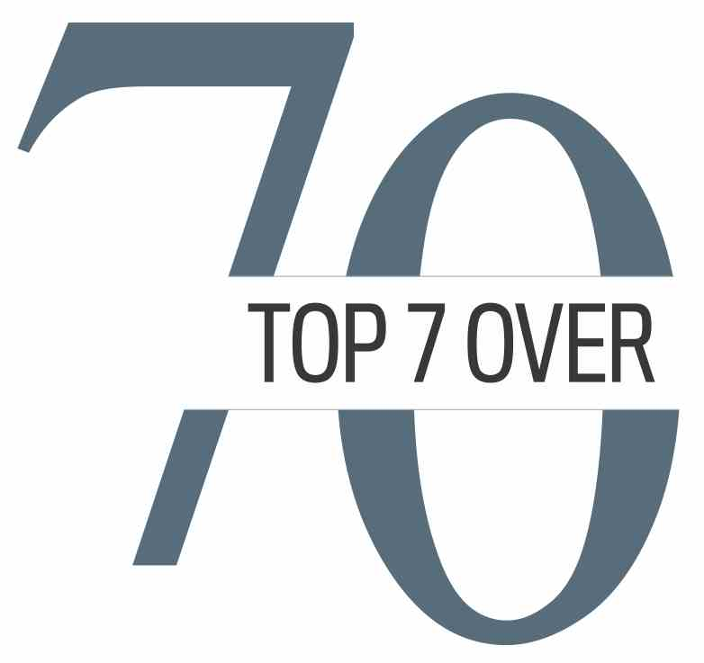
DEC. 2, 2020: NEWS RELEASE 10 a.m. embargo
Top 7 Over 70 launches 2021 awards program
& new ‘Noble Neighbour’ citations during pandemic
Website: www.top7over70.com

Watch our video announcement at 10 a.m. on Dec. 2 on our YouTube channel: https://youtu.be/t0IOjJOBrYo

And now, time for some better news . . . The Top 7 Over 70 program will be proceeding with its biennial awards!
While the coronavirus pandemic has led to the cancellation or postponement of numerous events, the third instalment of the Top 7 Over 70 will proceed as planned on Oct. 6, 2021.
“It is more important than ever that we celebrate the amazing accomplishments of one of our most important resources — older citizens,” said Top 7 Over 70 founder Jim Gray. “Despite difficult times, these folks are achieving remarkable results in business, the arts, science, philanthropy and more, for initiatives started after age 70.”
Nominations for the 2021 Top 7 Over 70 awards open today, with details at www.top7over70.com. (Format of the 2021 awards ceremony will be determined in accordance with health and safety guidelines in effect at that time next year.)
Also today, Top 7 Over 70 organizers are excited to unveil a second piece of good news. They’ve created a special citation program to recognize the community work of seniors during the pandemic — the Noble Neighbour Citations.
“We have seen so many seniors from all communities and all walks of life go above and beyond during the pandemic to help their neighbours,” said Top 7 Over 70 committee chairman Kim McConnell. “They're sewing masks, tutoring school children, fixing bikes, delivering groceries, providing relief child care services and much, much more. They are individuals who inspire us, lead by example and galvanize community action. We want to recognize them and recognize that we have much to celebrate, even during a pandemic.”
To set up interviews or book an interview for your show:
* To interview Kim McConnell, contact him at 403-862-5818; Kim@KimMcConnell.ca
* To interview Jim Gray, contact Barbara Surplus at 403-770-7207 or Barbara.surplus@brookfield.com
* Please feel free to use video from our YouTube channel or photos from our website Top7Over70.com, as required.
FAQS on the new Noble Neighbour Citations Program
Why has Top 7 Over 70 started the Noble Neighbour program?
We live in extraordinarily challenging times and we want to recognize some of the people doing extraordinary things to help their communities during this unique period. There are so many seniors stepping up and helping out, wherever and whenever they can. We want to recognize these contributions. Organizations everywhere are pivoting to respond to the pandemic. By quick-starting a new program to recognize Noble Neighbours, we are doing the same thing.

Does the Noble Neighbour program impact the biennial Top 7 Over 70 program?
No, not at all. The Top 7 Over 70 program is still going ahead as scheduled in 2021. The two programs are complementary. While Top 7 Over 70 awards require significant successes achieved by people after age 70, the Noble Neighbour program is a quick turn-around program that allows us to celebrate seniors in a different way. It allows us to reach into so many more communities and celebrate the rich offerings from all corners of our beautifully diverse population. Applying for a Noble Neighbour citation is a less intensive process than applying for a Top 7 Over 70 award. It doesn't require letters of nominations; just a few paragraphs on an application form that explain why a senior has proven to be a Noble Neighbour during the pandemic. Seniors can either apply for a citation on their own, or someone who knows them can apply for the citation on their behalf at top7over70.com.

How many Noble Neighbour Citations will be given out?
The number of citations awarded will depend on the quality of applications received. We plan on awarding a number of citations at the start of each month in the new year from January to June. Any senior in Calgary and area who has helped a neighbour or community during the pandemic is eligible to apply.

About the Top 7 Over 70 Awards
The biennial awards (occurring every two years) recognize seven individuals who are achieving excellence in one or more of a myriad of fields, focusing on achievements and enterprises started after age 70.
* For additional information, contact Monica at 403-875-1222 or top7over70@gmail.com.

