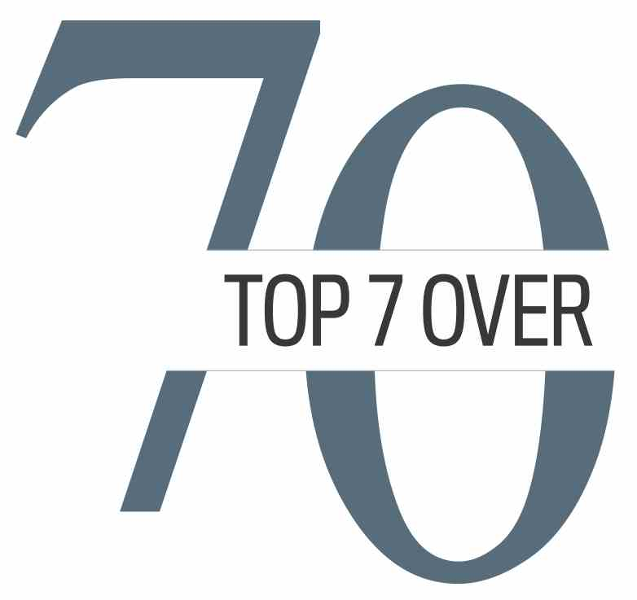

**SEPT. 18, 2017 / Updated Oct. 2, 2017**

**TOP 7 OVER 70 NEWS RELEASE**

**Calgary businesses show support for Top 7 Over 70**

Calgary’s corporate community has thrown its enthusiastic support behind the new Top 7 Over 70 project. Organizers were thrilled to announce that 38 sponsors and donors signed on to support the Top 7 Over 70, which is celebrating the accomplishments of local seniors and creating inter-generational mentorship programs to stimulate the economy.

“The vibrancy and innovative thinking of Calgary’s business community is unmatched,” said Top 7 Over 70 founder Jim Gray. “Each one of these sponsors is engaged in the community and committed to ensuring our city is moving forward in a positive direction.

“Their encouragement and support is what makes a new project, such as ours, a reality,” said Gray. “We are so very thankful and appreciative of their support.”

In addition to these sponsors, 52 individuals and corporations signed on as patrons to support the initiative.

**GOLD SPONSORS**

*  Alberta Blue Cross * ATB Financial * Brookfield Asset Management *

*  Calgary Economic Development * Calgary Herald  * CNRL (Canadian Natural Resources Limited)   * City of Calgary *  Corus * National Bank Private Banking 1859 * Optimum Talent-Conroy Ross * Willow Park Wines *

**SILVER SPONSORS & DONORS**

* Brian Felesky * Hyatt Regency Calgary * Jim Gray * Paul Giannelia *

**BRONZE SPONSORS & DONORS**

* Agriview Inc. * Alliance Pipeline * Alvin & Mona Libin Foundation * * Apple Magazine  * Barclays * Bonnie DuPont & Dr. Barry Bultz * Carraig Ridge * Charlie Fischer & Joanne Cuthbertson * Coril Holdings * David & Leslie Bissett * Deloitte * Enbridge * Garrett Agencies * Jim Artindale *Mary Rozsa de Coquet * McCann Family Foundation * MNP * Saju Holdings Ltd. * Shoppers Drug Mart * The Calgary Foundation * Tokay Capital Corp * West Canadian Digital Imaging *

**TOP 7 OVER 70 GOLD SPONSORS**

** **

** **

** **

** **

** **



**SILVER SPONSORS & DONORS**



Brian Jim Paul

Felesky Gray Giannelia

**BRONZE SPONSORS & DONORS**

* Agriview Inc. * Alvin & Mona Libin Foundation * Bonnie DuPont & Dr. Barry Bultz * Carraig Ridge * David & Leslie Bissett * Charlie Fischer & Joanne Cuthbertson *  Jim Artindale * Mary Rozsa de Coquet * McCann Family Foundation * Saju Holdings Ltd. * Tokay Capital *

  

 

  



**PATRONS**

*  Adam Legge * AgeCare * Alan Smith * Allen Hagerman * Ann McCaig * Aspen Properties Ltd. * Bill Andrew  * Bill Lister * Bill & Toshimi Sembo * Bob Brawn * Bob Gibson * Bluesky Equities Ltd. * Brad Zumwalt * Cal Wenzel * Catherine Evamy * Cheryl Hamelin  * Chris Robb * Dan Hays * Dave Robson * Dave Werklund * David Chalack  * Dick Haskayne * Don Douglas * Doug Hunter * Gerald J. Maier * Gerry Wood * Heather Shaw * Ian MacGregor * Irfhan Rawji * Jeff McCaig * Jerilyn Wright & Associates *  Linda McNally * Mac Van Wielingen * Marcel Coutu * Margaret Southern * McCarthy Tétrault * Peters & Co. * Renfrew Educational Services * Richard & Cathy Bird * Robert G. Peters * Ron Ghitter * Ross Glen * Sam Kolias *  Scott Hutcheson * Sharon Siebens * 6IX Passions * Steve Allan * The Myron & Catherine Tétreault Foundation * Timothy Hearn * Tom & Deb Mauro *  Trico Homes * W. Brett Wilson *